Weather-Based Prediction of Wind Turbine Energy-PROJECT REPORT
1.Introduction
1.1 Project Overview
The Weather-Based Prediction of Wind Turbine Energy project uses Machine Learning to estimate wind turbine power output. It is built using a trained regression model based on wind speed and theoretical power data. The model is integrated into a Flask web application for real-time predictions. Users can enter input values through a simple interface and instantly view energy output results. This project demonstrates the practical application of AI in renewable energy forecasting.
1.2 Purpose
The purpose of this project is to predict wind turbine energy output using machine learning techniques. It aims to provide a simple web-based system for real-time energy prediction based on wind parameters. The project also promotes the use of data-driven solutions in renewable energy management.
2. IDEATION PHASE
2.1 Problem Statement
Wind energy generation depends heavily on environmental conditions such as wind speed and turbine performance characteristics. Accurately predicting the power output of a wind turbine is essential for energy planning, grid management, and improving renewable energy efficiency. However, traditional estimation methods are often manual, time-consuming, and lack precision. Therefore, there is a need for an automated, data-driven system that can predict wind turbine energy output quickly and accurately using machine learning techniques.
2.2 Empathy Map Canvas
User: Renewable energy researcher
- Think & Feel: Wants accurate and reliable predictions of wind energy output. Feels motivated to use technology for improving renewable energy efficiency.
- See: Sees a simple web interface where wind parameters can be entered easily. Observes prediction results displayed clearly and instantly.
- Say & Do: Inputs wind speed and theoretical power values to check energy output. Uses the system for learning, research, or analysis purposes.
- Hear: Learns about the importance of renewable energy and smart forecasting methods. Gets feedback from the system through prediction results.
- Pain: Manual calculations are complex and time-consuming. Lack of easy tools to predict wind turbine performance.
- Gain: Quick and accurate energy predictions. Better understanding of wind energy behavior using machine learning.

2.3 Brainstorming

Key Ideas Brainstormed
- Automated Wind Energy Prediction – Use machine learning to automatically estimate wind turbine power output instead of manual calculations.
- Simple Web Interface – Provide an easy-to-use web application where users can input parameters and get instant results.
- Real-Time Prediction System – Enable users to receive predictions immediately after entering wind-related values.
- Data-Driven Renewable Energy Tool – Build a system that promotes the use of data science in sustainable energy solutions.
- Educational & Research Support – Design the project to help students and researchers understand how ML can be applied in the renewable energy domain.

3. REQUIREMENT ANALYSIS

  - Customer Journey Map

- Learns about the wind energy prediction system as a tool for estimating turbine power output using machine learning.
- Opens the web application and understands that wind parameters can be entered for prediction.
- Enters wind speed and theoretical power values into the input fields.
- Submits the form to generate a prediction using the trained ML model.
- Views the predicted wind turbine energy output displayed on the screen.
- Uses the result to understand how wind conditions affect energy generation.
- Repeats the process with different values to compare and analyze outputs.
- Gains better insight into renewable energy forecasting and machine learning applications.
  - Solution Requirement
Functional Requirements:

- User Input of Wind Parameters
- Fetch Weather Data from API
- Display Current Weather Conditions
- Machine Learning–Based Energy Prediction
- Display Predicted Wind Turbine Power Output
- Error Handling for Invalid Inputs
- Load and Use Pre-trained ML Model
- Interactive Web Interface for Prediction
- Session-Based Storage of Input and Results
- Real-Time Prediction Response
- Reset / New Prediction Option

Non Functional Requirements
- Performance
- Usability
- Reliability
- Scalability
- Security
- Availability
- Maintainability
- Compatibility
3.3Data Flow Diagram
Level 1 DFD:
  - User interacts with the Frontend (Flask Web Interface)
  - Frontend sends input data (wind speed & theoretical power) to Backend (Flask Server)
  - Backend processes the request and sends data to the Machine Learning Model
  - ML Model predicts wind turbine energy output
  - Backend sends prediction result back to Frontend for display
3.4 Technology stack
Frontend
- HTML5 – Used to design the structure of web pages
- CSS3 – Used for styling and improving the user interface.
- Jinja2 – Template engine used to display dynamic data in HTML pages.
Backend
- Python – Core programming language used for application logic.
- Flask – Lightweight web framework used to handle routing and server-side processing.
Machine Learning
- Scikit-learn – Used to train the regression model for wind energy prediction.
- Joblib (.pkl file) – Used to save and load the trained machine learning model.
API Integration
- OpenWeatherMap API – Used to fetch real-time weather data (temperature, humidity, pressure, wind speed).

Development Tools
- Visual Studio Code – Code editor used for development.
- Git & GitHub – Version control and project management.
- Python Virtual Environment – For managing project dependencies.

4. PROJECT DESIGN
4.1 Problem–Solution Fit
Problem
Wind energy production depends heavily on environmental factors such as wind speed, temperature, humidity, and atmospheric pressure. Predicting the actual energy output of wind turbines is challenging due to the variability of weather conditions. Traditional estimation methods may not provide accurate or real-time predictions.
Energy planners and researchers require a system that can:
- Fetch live weather data
- Analyze environmental parameters
- Predict wind energy output accurately
- Provide a user-friendly interface

Solution Fit
The Wind Energy Prediction Web Application solves this problem by:
- Integrating real-time weather data using a weather API
- Applying a trained machine learning regression model
- Providing instant energy output predictions
- Offering a simple web-based interface
This ensures accurate, fast, and practical wind energy estimation.
4.2 Proposed Solution
The proposed system is a web-based application that combines:
- Live Weather Data Retrieval
The system fetches real-time weather data (temperature, humidity, pressure, wind speed) from a weather API based on the selected city.
- Machine Learning Prediction Model
A trained regression model predicts wind turbine energy output using wind speed and theoretical power as inputs.
- User Interface
The web interface allows users to:
  - Select a city
  - View current weather conditions
  - Enter turbine-related inputs
  - Get predicted energy output
The application ensures both weather monitoring and energy prediction are displayed simultaneously for better analysis.
4.3 Solution Architecture
System Components
- Frontend Layer
  - HTML
  - CSS
  - Jinja Templates
  - Displays weather and prediction results
- Backend Layer
  - Flask Framework
  - Handles routing (/windapi, /y_predict)
  - Manages session storage
- Machine Learning Layer
  - Pre-trained regression model
  - Saved as .pkl file
  - Loaded using Joblib

- External API Layer
  - Weather API (OpenWeatherMap)
  - Provides real-time environmental data
Architecture Flow
User → Web Interface → Flask Backend →Weather API → Weather Data →Machine Learning Model→Prediction →Results Displayed on Web Page
Data Flow
- User selects city
- Weather API returns live weather data
- User enters wind speed & theoretical power
- ML model processes inputs
- Energy prediction is generated
- Weather + Prediction displayed together

5. PROJECT PLANNING & SCHEDULING
5.1 Project Planning
Project divided into 4 sprints:
Sprint 1: Collect dataset, clean data, and explore features related to wind energy generation.
Sprint 2: Train and evaluate machine learning model for wind turbine power prediction.
Sprint 3: Develop Flask web application and integrate trained ML model.
Sprint 4: Test system performance, refine UI, upload project to GitHub, and prepare demo & documentation.
6. FUNCTIONAL AND PERFORMANCE TESTING
6.1 Performance Testing
• Tools Used: Flask Debug Logs, Browser Developer Tools (Chrome Dev Tools), and local system testing.
• Test Cases: Tested prediction response time, input validation, model accuracy with sample inputs, and weather API response handling.
• Outcome: Achieved quick prediction response (within a few seconds), stable system performance, and correct output for valid inputs.
7. RESULTS
7.1 Output Screenshots
• Home Page of Web Application
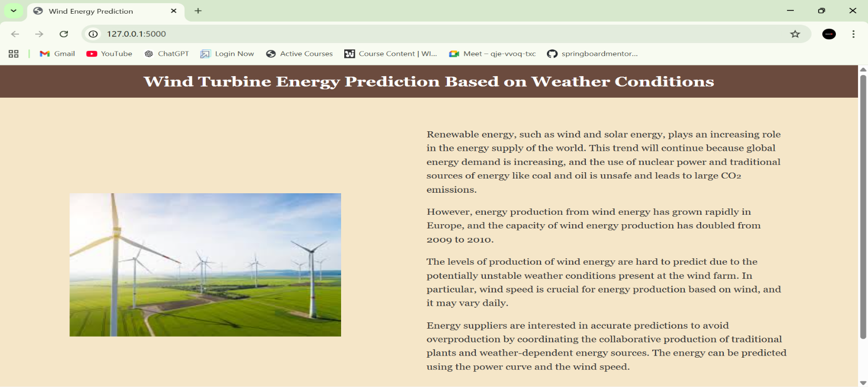
• Weather Information Display Section
• Wind Energy Prediction Input Form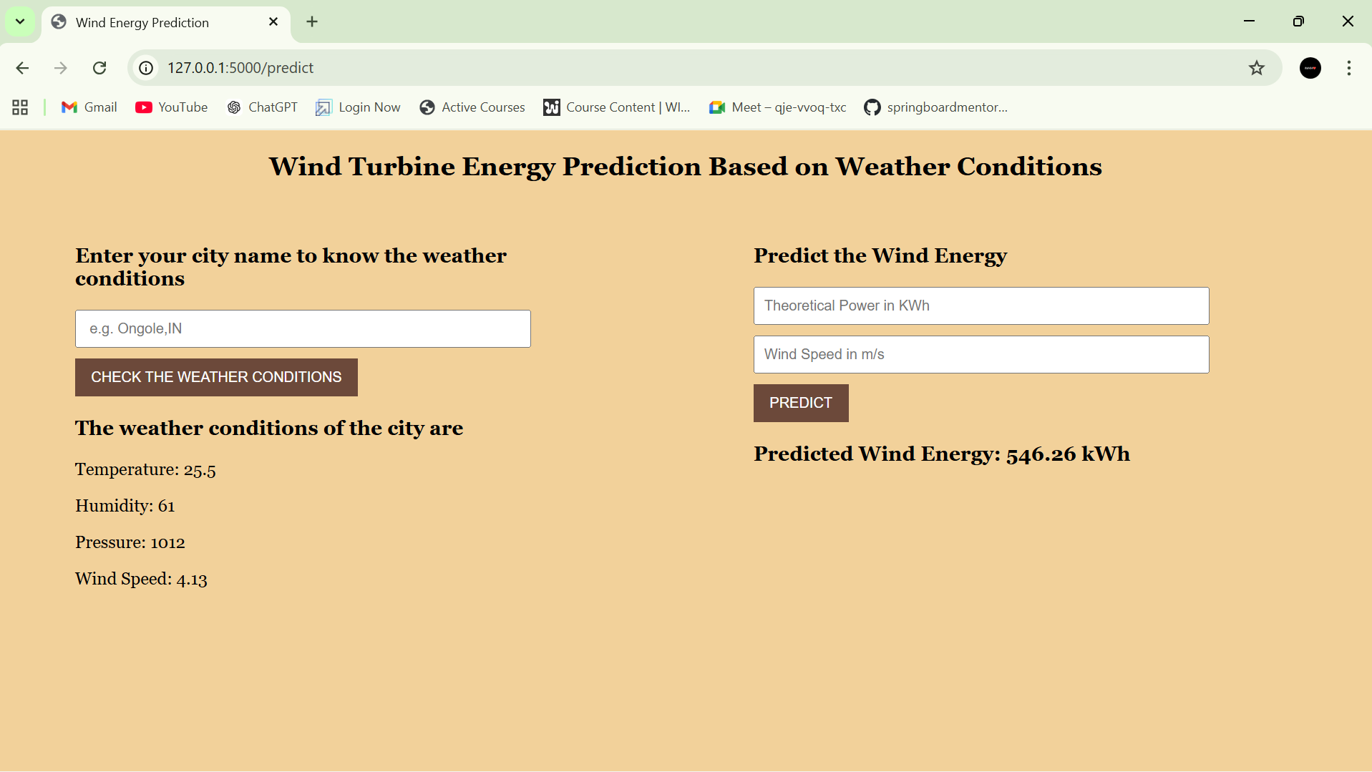

• Predicted Energy Output Display
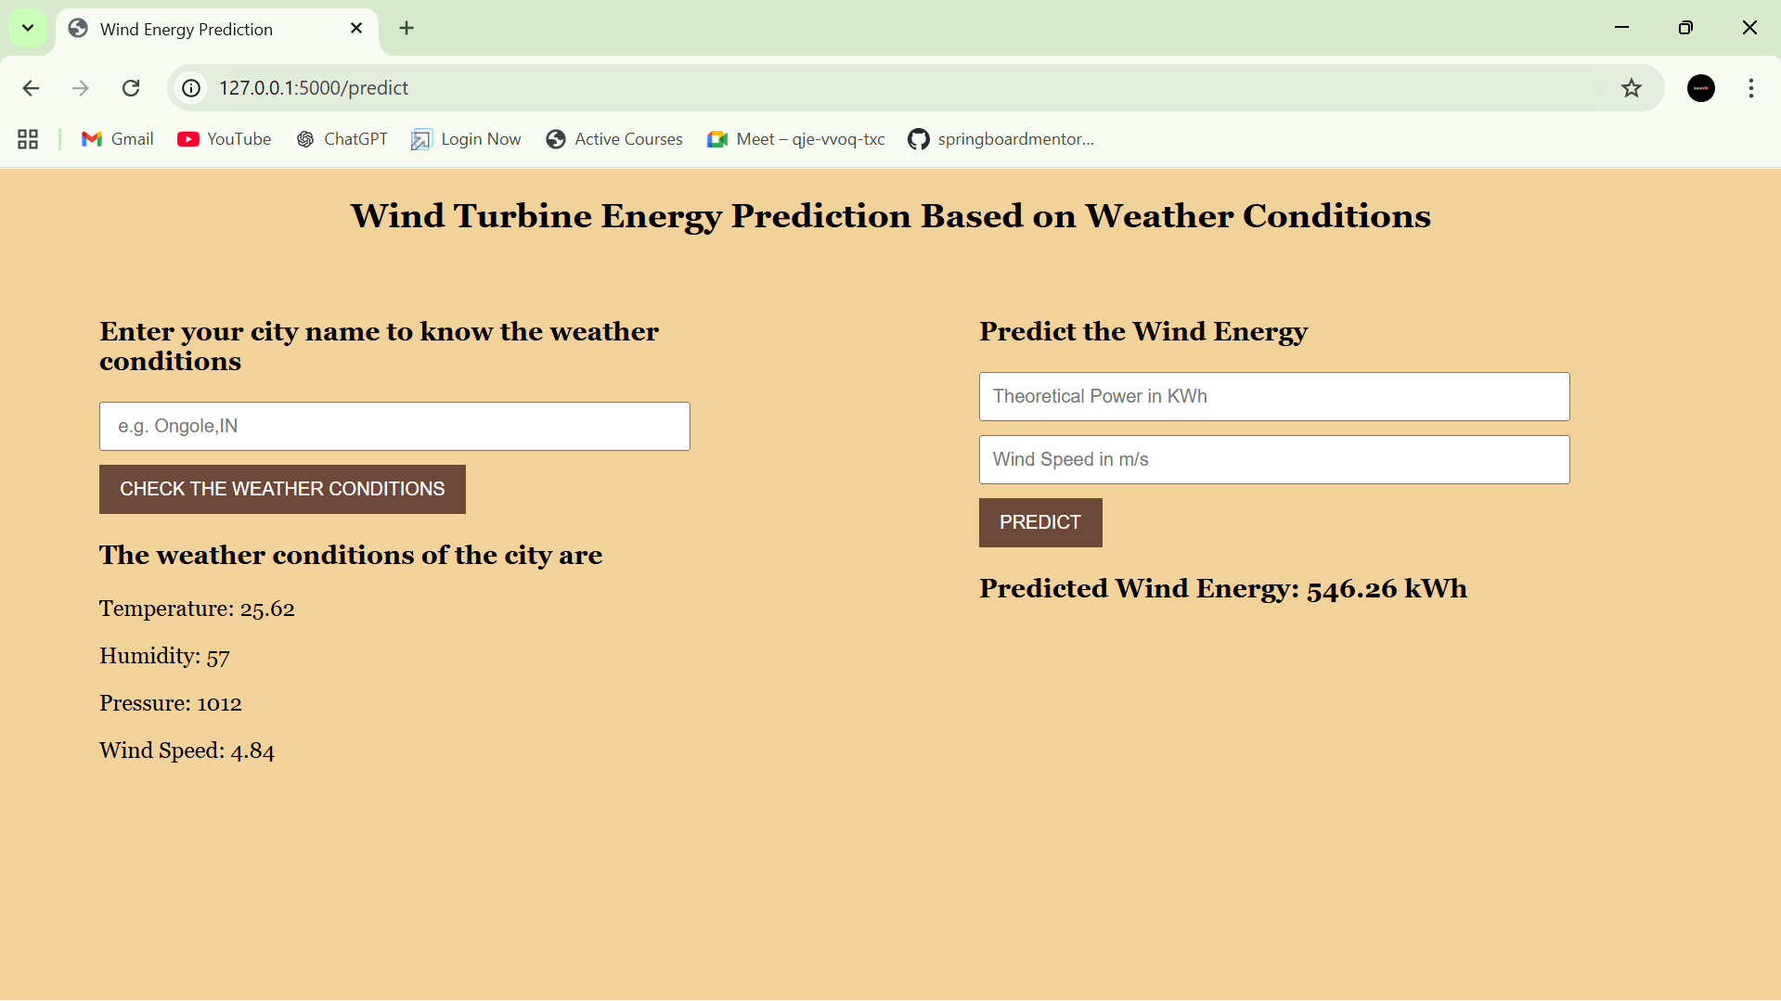

8. ADVANTAGES & DISADVANTAGES
Advantages:
• User-friendly web interface
• Real-time wind energy prediction
• Integration of machine learning with web application
• Lightweight and easy to deploy
• Promotes renewable energy awareness
Disadvantages:
• Limited to selected input parameters
• Depends on quality of training data
• No real-time turbine sensor integration
• Weather API dependency for environmental data

9. CONCLUSION
The Wind Energy Prediction System demonstrates how machine learning can be used to estimate wind turbine power output efficiently. By combining data analysis, model training, and web integration, the project provides a practical tool for understanding renewable energy forecasting. The system is simple, fast, and accessible, making it useful for educational and research purposes.

10. FUTURE SCOPE
• Add more weather parameters (temperature, humidity, pressure) to improve accuracy
• Deploy the application on a cloud platform
• Use advanced ML or deep learning models
• Integrate real-time turbine or IoT sensor data
11. APPENDIX
S.No | Items | Details
1 | Project Title | Weather-Based Prediction of Wind Turbine Energy
2 | Team ID | LTVIP2026TMIDS67101
3 | Team Members | Shaik Dariya Vali  Thalluri Sri Kalyan  Kavati Srinadh  Pallapothu Hemanth Satya Subramanyam
4 | Technology Stack | Python, Flask, Scikit-learn, Pandas, NumPy, HTML, CSS
5 | Repository Link | GitHub Project Link
6 | Project Demo | Demo Video Link
7 | Development Tools | Visual Studio Code, GitHub, Python
8 | Testing Tools | Flask Debug Mode, Browser Developer Tools

THANK YOU

